**Assignment –**

1. **ApexaiQ Overview:**

ApexaiQ is a **SaaS-based IT risk management platform** that calculates your **ApexaiQ score**, a credit rating for your IT environment. It assesses **risks, compliance, obsolescence, maintenance, and vulnerabilities** in a single dashboard, helping organizations improve their IT hygiene.

1. **Major clients**

* **Fidelity Bank**
* **Northern Bank**
* **Beazley (Cybersecurity Expert Vendor)**

These clients represent industries such as **banking, financial services, healthcare, and insurance.**

1. **Features of Dashboard:**

* **Comprehensive IT Visibility** – Monitors laptops, servers, routers, cloud, and IoT devices.
* **Real-Time Risk Assessment** – Identifies obsolete hardware/software, expiring warranties, and security vulnerabilities.
* **IT Security Gaps** – Highlights non-compliant devices and allows setting compliance benchmarks.
* **Actionable Insights** – Prioritizes critical vulnerabilities for patching.
* **Automated Alerts** – Sends notifications for non-compliant devices.

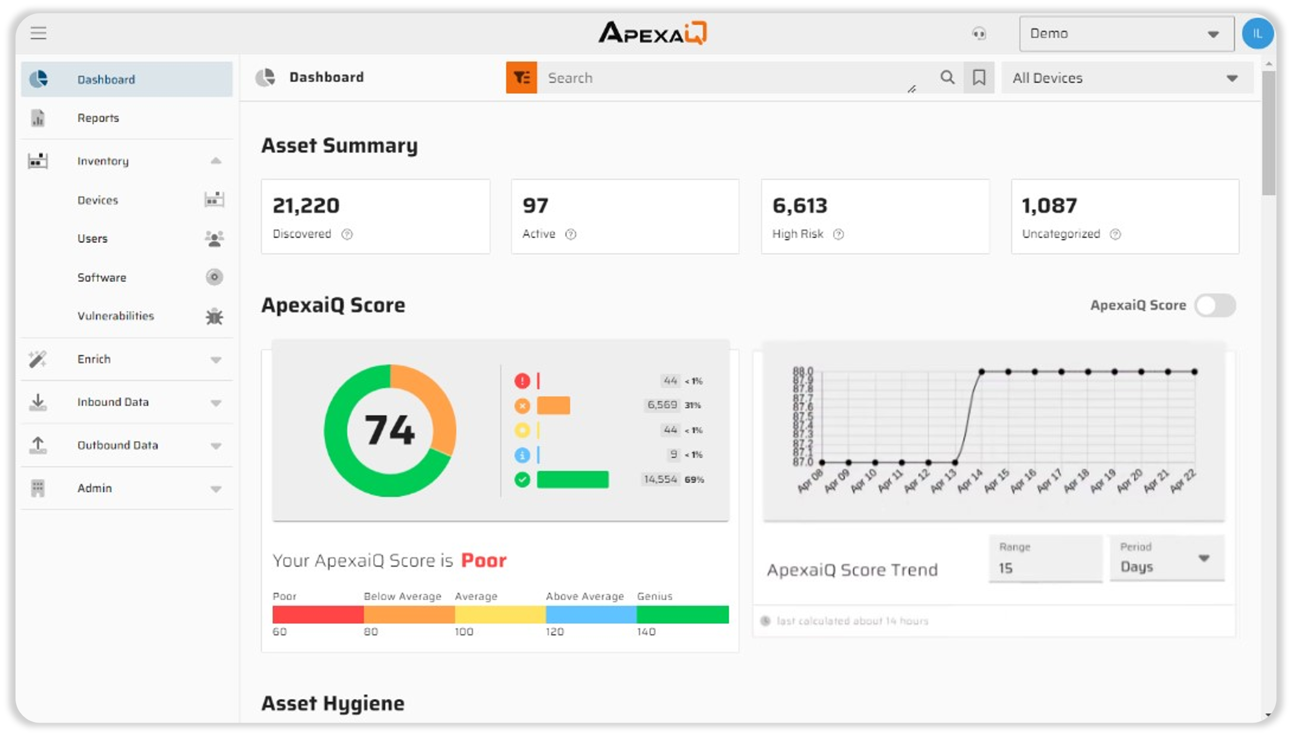

* It computes all your risks and security gaps into a single score, based on the most vital obsolescence and compliance factors.
* The higher the score, the stronger and more secure your IT environment.

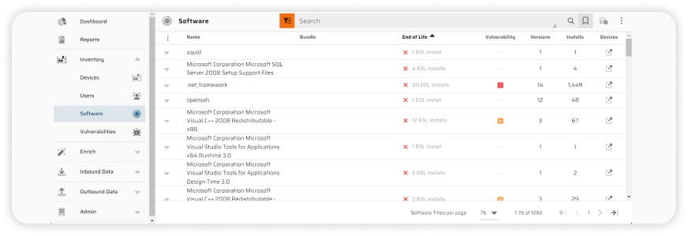

Gain visibility into licenses, versions, and vulnerabilities across your entire stack.

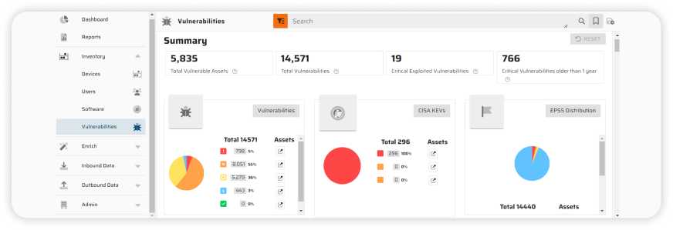

Never miss a critical update that could leave you exposed.

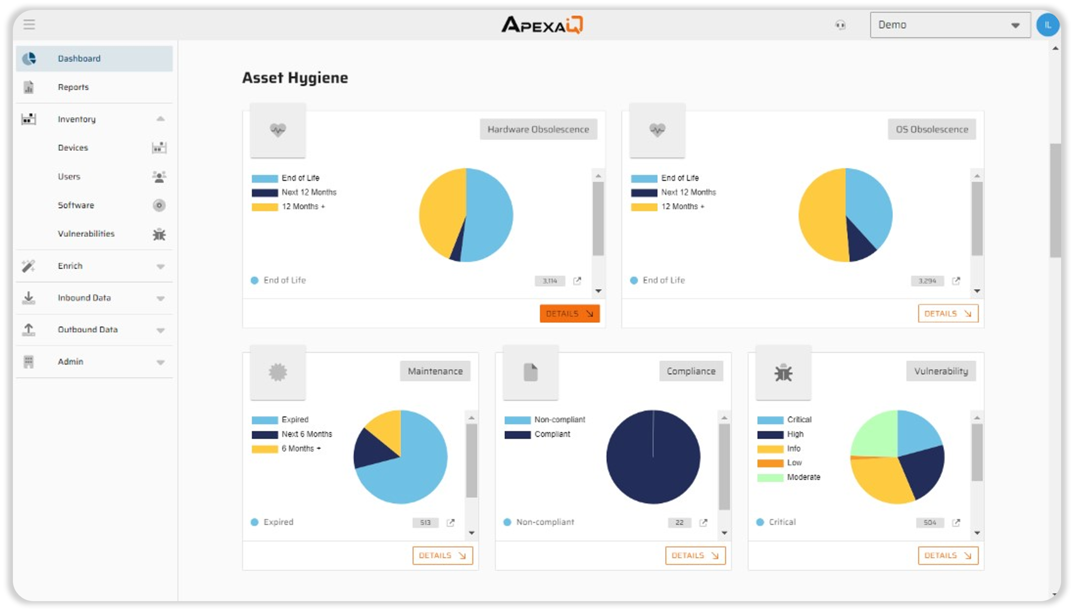

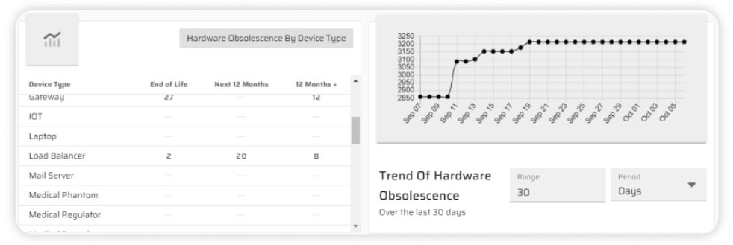

From servers to IoT devices, know exactly what you have and its health status.

1. **ApexaiQ vs. Competitors –**

* **Source:** [CB Insights](https://www.cbinsights.com/company/apexa-iq/alternatives-competitors)
* **Focus:** While all three operate in the cybersecurity space, they specialize in slightly different areas.
  + ApexaiQ focuses on overall IT asset security and compliance,
  + Quod Orbis emphasizes continuous security monitoring,
  + Vicarius concentrates on vulnerability management.
* **Key Strength:** This highlights each product's core competency.
  + ApexaiQ excels at real-time asset monitoring,
  + Quod Orbis at compliance and risk monitoring,
  + Vicarius at AI-driven vulnerability remediation.

* **Asset Discovery:** All three offer asset discovery capabilities.
  + ApexaiQ provides full IT asset visibility,
  + Quod Orbis performs broad IT scanning,
  + and Vicarius focuses on software vulnerability detection.

While there's overlap, the *scope* of what they discover might differ. For example, ApexaiQ might be more comprehensive across all asset types, while Vicarius might go deeper into software vulnerabilities specifically.

* **Monitoring:**
  + ApexaiQ offers continuous real-time tracking,
  + Quod Orbis provides risk analysis and compliance alerts,
  + Vicarius emphasizes automated patching and scanning.

Again, all three "monitor," but *what* they monitor and *how* they do it varies.

* **Compliance:**
  + ApexaiQ generates automated reports for standards like ISO and GDPR.
  + Quod Orbis focuses on regulatory security compliance,
  + Vicarius on vulnerability compliance.

They each address compliance, but with a different emphasis.

* **Best For:** This summarizes the ideal use case for each product.
  + ApexaiQ is best for organizations needing full IT security and risk insights,
  + Quod Orbis for those requiring enterprise security monitoring,
  + Vicarius for those prioritizing automated vulnerability patching.

**In essence:**

* **ApexaiQ** is the most comprehensive, offering a broad view of IT asset security and compliance. Think of it as a holistic platform.
* **Quod Orbis** is geared towards continuous security monitoring, likely providing in-depth analysis and alerts related to security posture and risk.
* **Vicarius** is more specialized, focusing on identifying and remediating vulnerabilities, particularly in software.

The best choice for a particular organization depends on their specific security needs and priorities. A company needing a broad overview of their IT security posture might choose ApexaiQ. One focused on meeting specific regulatory requirements might lean towards Quod Orbis. And a company struggling with patching vulnerabilities quickly might find Vicarius the best fit.